For question 1 I decided to implement the Prototype pattern for the default playable. I added a default Playable object to the library and a getDefaultPlayable() method. I added constructors for the client to give the default as a parameter, if no default is specified I decided to make the default a song. I also added clone() methods to all playables so the client can clone the default playable.

For question 2 I decided to use the command pattern. I created a command interface for state changing methods, and concrete command classes within the PlayList class. This way I can store the concrete methods in arraylists and track previous states.

Line coverage: 87% (for all classes)

Branch coverage: 17% (for all classes), 45% (of PlayList class)

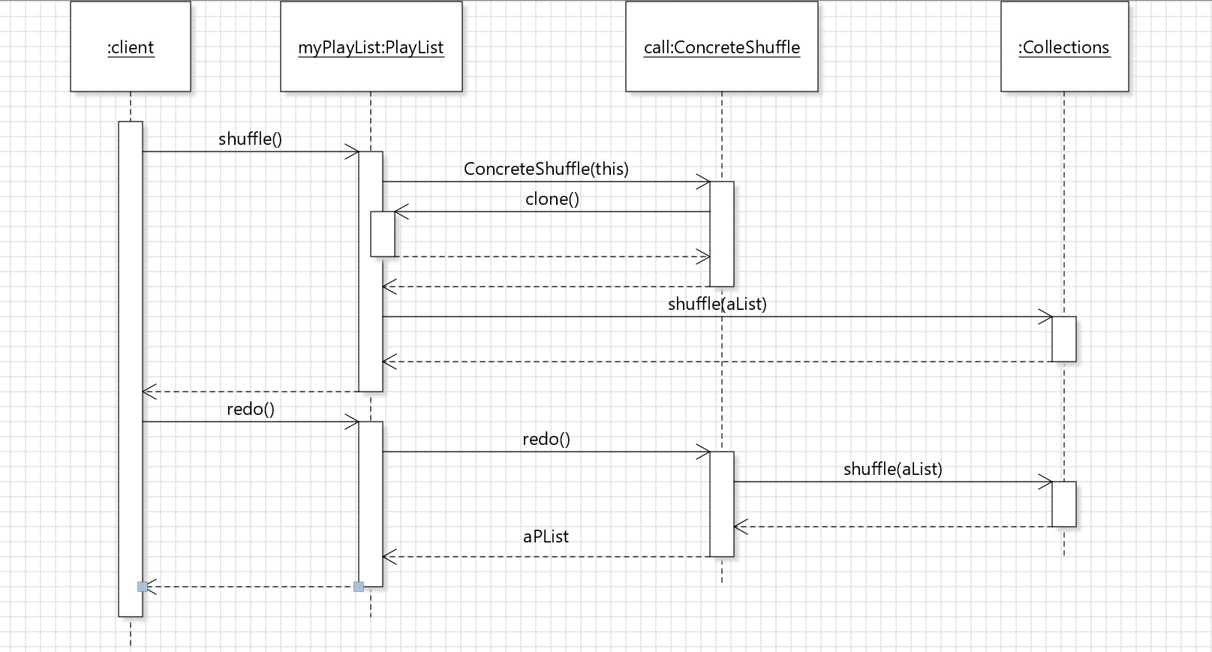

Sequence diagram for shuffle() followed by redo()